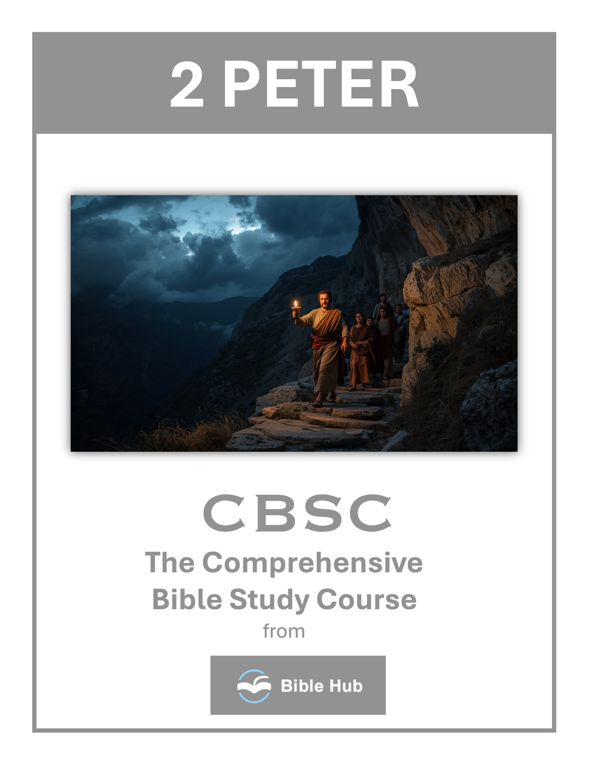

2 Peter 1 Teaching Points and Bible Study Questions
Embrace the Gift of Faith
In 2 Peter 1:1, we are reminded of the precious faith we have received through the righteousness of our God and Savior, Jesus Christ. This faith is not something we earn but a divine gift that empowers us to live a life pleasing to God. Embrace this gift with gratitude, knowing that it is the foundation of your spiritual journey.
1. How can you actively nurture and strengthen your faith in daily life?
2. Why do you think embracing faith is essential for personal growth and spiritual maturity?
3. What practical steps can you take to apply faith in challenging situations?
Grow in Grace and Peace
Verse 2 encourages us to multiply grace and peace in our lives through the knowledge of God and Jesus our Lord. This growth is not passive; it requires intentional pursuit of understanding and relationship with God. As you deepen your knowledge of Him, you will find your life enriched with His grace and peace.
1. How can you actively cultivate grace and peace in your daily interactions with others?
2. Why do you think growing in grace and peace is essential for spiritual maturity?
3. What practical steps can you take to increase grace and peace in challenging situations?

Partake in Divine Nature
2 Peter 1:4 speaks of the incredible promise that we can partake in the divine nature, escaping the corruption in the world caused by evil desires. This is a call to live a life that reflects God's character, empowered by His promises. Let this truth inspire you to rise above worldly temptations and live a life of holiness.
1. How can you actively partake in the divine nature in your daily life?
2. What steps can you take to escape worldly corruption and embrace divine nature?
3. Why do you think partaking in divine nature is essential for spiritual growth?
Add to Your Faith
Verses 5-7 outline a progression of virtues to add to your faith: goodness, knowledge, self-control, perseverance, godliness, brotherly kindness, and love. Each of these qualities builds upon the other, creating a robust and mature faith. Make it a daily goal to cultivate these virtues, allowing them to transform your character.
1. How can you actively add virtue to your faith in daily life situations?
2. Why do you think knowledge is essential to strengthen your faith journey?
3. What practical steps can you take to develop self-control in challenging circumstances?

Be Effective and Fruitful
In verse 8, Peter assures us that possessing these qualities in increasing measure will keep us from being ineffective and unproductive in our knowledge of Jesus Christ. Strive to be fruitful in your spiritual walk, knowing that your growth glorifies God and impacts those around you.
1. How can you apply the qualities in 2 Peter 1 to be more effective in your daily life?
2. Why do you think cultivating these virtues leads to a more fruitful spiritual journey?
3. What steps can you take to ensure you are growing in knowledge and effectiveness as a believer?
Remember Your Cleansing
Verse 9 warns against forgetting the cleansing from past sins. Remembering the forgiveness and grace you've received keeps you humble and grateful. It also motivates you to extend the same grace to others, fostering a spirit of compassion and understanding.
1. How can remembering your cleansing influence your daily decisions and interactions with others?
2. Why do you think it's important to continually remind yourself of your spiritual cleansing?
3. What practical steps can you take to ensure you don't forget your cleansing and its significance?

Make Your Calling Sure
2 Peter 1:10 urges us to be diligent in confirming our calling and election. This is not about earning salvation but living in a way that reflects the certainty of your faith. By doing so, you will never stumble, and your life will be a testament to God's faithfulness.
1. How can you actively cultivate the qualities listed in 2 Peter 1 to strengthen your faith?
2. Why do you think making your calling sure is emphasized as crucial for spiritual growth?
3. What practical steps can you take daily to confirm your calling and election?
Anticipate a Rich Welcome
Verse 11 promises a rich welcome into the eternal kingdom of our Lord and Savior, Jesus Christ, for those who live faithfully. Let this assurance fill you with hope and motivation to persevere, knowing that your efforts are not in vain and that a glorious future awaits.
1. How can you actively prepare for a rich welcome into God's eternal kingdom in daily life?
2. Why do you think cultivating virtues leads to a more fulfilling spiritual journey?
3. What practical steps can you take to ensure your faith remains effective and productive?

Hold Fast to the Truth
Peter emphasizes in verses 12-15 the importance of being reminded of the truth, even if you are already established in it. Regularly revisit the foundational truths of your faith to keep them fresh in your mind and heart. This practice will anchor you in times of doubt and challenge.
1. How can you actively ensure you are holding fast to the truth in your daily life?
2. Why do you think it's important to remember past teachings to hold fast to the truth?
3. What practical steps can you take to discern truth from falsehood in today's world?
Trust the Prophetic Word
Finally, in verses 19-21, Peter highlights the reliability of the prophetic word, which shines like a lamp in a dark place. Trust in the Scriptures, knowing that they are inspired by the Holy Spirit and provide guidance and wisdom for every aspect of life. Let the Word of God illuminate your path and direct your steps.
1. How can you apply the prophetic word to strengthen your daily faith journey?
2. Why do you think trusting the prophetic word is essential for spiritual growth?
3. What can you do to discern and trust true prophetic messages in your life?

2 Peter 2 Teaching Points and Bible Study Questions
Beware of False Teachers
In 2 Peter 2, we are warned about the presence of false teachers among us. These individuals will "secretly introduce destructive heresies" (2 Peter 2:1). It's crucial to stay vigilant and grounded in Scripture, ensuring that our beliefs align with the truth of God's Word. By doing so, we protect ourselves from being led astray by teachings that deviate from the gospel.
1. How can you discern false teachings in today's world and protect your faith community from them?
2. Why do you think false teachers are appealing, and how can you resist their influence?
3. What practical steps can you take to ensure your beliefs align with biblical truth?
The Danger of Denying the Master
Peter highlights the grave danger of denying the Lord who bought us. He writes, "They will even deny the Master who bought them, bringing swift destruction on themselves" (2 Peter 2:1). This serves as a reminder to hold fast to our faith in Jesus Christ, acknowledging Him as our Savior and Lord in every aspect of our lives.
1. How can you recognize and avoid false teachings that deny the Master in your daily life?
2. Why do you think denying the Master is a prevalent temptation in today's society?
3. What steps can you take to strengthen your faith and prevent denying the Master?

The Power of God's Judgment
God's judgment is both just and inevitable. Peter reminds us that "their condemnation has long been hanging over them, and their destruction has not been sleeping" (2 Peter 2:3). This underscores the importance of living righteously and being mindful of our actions, knowing that God sees all and will judge accordingly.
1. How can understanding God's judgment in 2 Peter 2 influence your daily decision-making?
2. Why do you think God's judgment is portrayed as both powerful and just in this chapter?
3. What can you learn from 2 Peter 2 about avoiding false teachings in your life?
The Example of the Fallen Angels
Peter uses the example of the angels who sinned to illustrate the certainty of God's judgment. "For if God did not spare the angels when they sinned, but cast them deep into hell" (2 Peter 2:4), we too must be aware that no one is beyond accountability. This serves as a sobering reminder to live in obedience to God's commands.
1. How can the example of fallen angels influence your understanding of accountability in your daily life?
2. Why do you think recognizing consequences is important in making ethical decisions today?
3. What can you learn from the fallen angels about resisting temptation in your own life?

The Deliverance of the Righteous
Amidst warnings of judgment, Peter also offers hope by highlighting God's deliverance of the righteous. He recalls how God "rescued righteous Lot" (2 Peter 2:7), demonstrating that God knows how to rescue the godly from trials. This assurance encourages us to remain steadfast in our faith, trusting in God's protection and deliverance.
1. How can you identify and avoid false teachings to ensure your deliverance as a righteous person today?
2. Why do you think God delivers the righteous from trials, and how does this impact your faith?
3. What can you do daily to align yourself with God's promise of deliverance for the righteous?
The Corruption of False Teachers
Peter vividly describes the corrupt nature of false teachers, stating that "they are like unreasoning animals" (2 Peter 2:12). Their actions are driven by instinct rather than truth. This serves as a caution to discern the character and motives of those who claim to teach God's Word, ensuring they align with biblical principles.
1. How can you discern false teachings in your daily life and protect your faith community?
2. Why do you think false teachers are often persuasive, and how can you resist their influence?
3. What practical steps can you take to ensure you are following true teachings?

The Deceptive Allure of Sin
Sin often presents itself as enticing, but Peter warns of its destructive consequences. He writes, "They promise them freedom, while they themselves are slaves to corruption" (2 Peter 2:19). This reminds us to be wary of temptations that promise fulfillment but ultimately lead to spiritual bondage.
1. How can you recognize and resist the deceptive allure of sin in daily life?
2. Why do you think sin often appears more appealing than righteousness?
3. What practical steps can you take to avoid being misled by false teachings?
The Importance of Knowing the Truth
Peter emphasizes the significance of knowing and adhering to the truth. He states, "For if they have escaped the corruption of the world through the knowledge of our Lord and Savior Jesus Christ" (2 Peter 2:20). This highlights the transformative power of knowing Christ and the importance of growing in our understanding of His Word.
1. How can knowing the truth protect you from false teachings in your daily life?
2. Why do you think it's crucial to discern truth in today's information age?
3. What steps can you take to deepen your understanding of biblical truth?

The Tragic State of Apostasy
Apostasy, or falling away from the faith, is a tragic state that Peter warns against. He describes it as being "worse for them than if they had never known the way of righteousness" (2 Peter 2:21). This serves as a sobering reminder to persevere in our faith and remain committed to following Christ.
1. How can you guard against false teachings in your daily life to prevent apostasy?
2. Why do you think people are drawn to teachings that lead to apostasy?
3. What steps can you take to strengthen your faith and avoid spiritual downfall?
The Call to Remain Faithful
Ultimately, 2 Peter 2 calls us to remain faithful to the truth of the gospel. By staying rooted in Scripture and vigilant against false teachings, we can navigate the challenges of this world with confidence. Let us hold fast to our faith, trusting in the promises of God and the hope of eternal life through Jesus Christ.
1. How can you identify and resist false teachings to remain faithful in your daily life?
2. Why do you think remaining faithful is challenging in today's world, and how can you overcome these challenges?
3. What practical steps can you take to strengthen your faith and avoid being led astray?

2 Peter 3 Teaching Points and Bible Study Questions
Remember the Words of the Prophets and Apostles
In 2 Peter 3:2, we are reminded to "recall the words spoken in the past by the holy prophets and the commandment of our Lord and Savior through your apostles." This is a call to anchor ourselves in the truth of Scripture, which is consistent and unchanging. By immersing ourselves in the Bible, we can navigate life's challenges with wisdom and clarity, knowing that God's Word is a reliable guide.
1. How can you actively remember and apply the teachings of the prophets and apostles in daily life?
2. Why do you think it's important to recall the words of the prophets and apostles today?
3. What practical steps can you take to ensure the teachings of the apostles influence your decisions?
Be Aware of Scoffers
Peter warns us in 2 Peter 3:3-4 that "scoffers will come in the last days with scoffing, following their own sinful desires." These individuals will question the promise of Christ's return, but we must stand firm in our faith. Recognize that skepticism is part of the spiritual landscape, and use it as an opportunity to deepen your understanding and commitment to the truth.
1. How can you remain steadfast in your faith when faced with scoffers in your daily life?
2. Why do you think scoffers challenge the promise of Christ's return, and how should you respond?
3. What practical steps can you take to strengthen your belief in God's promises despite skepticism?

God's Timing is Perfect
In 2 Peter 3:8, we are reminded that "with the Lord a day is like a thousand years, and a thousand years are like a day." God's timing is not our timing, and His plans unfold according to His perfect wisdom. Trust in His timing, knowing that He is sovereign and His purposes will be fulfilled in due course.
1. How can you trust God's timing in situations where you feel impatient or uncertain?
2. Why do you think God's timing might differ from your own expectations or plans?
3. What can you do to align your daily life with the belief that God's timing is perfect?
The Lord's Patience is Salvation
Peter emphasizes in 2 Peter 3:9 that "the Lord is not slow in keeping His promise, as some understand slowness. Instead, He is patient with you, not wanting anyone to perish, but everyone to come to repentance." God's patience is an expression of His love and desire for all to be saved. Use this time to share the Gospel and encourage others to turn to Christ.
1. How can you apply the concept of the Lord's patience in your daily interactions with others?
2. Why do you think understanding God's patience can change your perspective on personal challenges?
3. What can you do to align your life with the idea that the Lord's patience is salvation?

The Day of the Lord Will Come Unexpectedly
2 Peter 3:10 tells us that "the day of the Lord will come like a thief." This serves as a reminder to live each day with readiness and anticipation. We should be vigilant in our faith, always prepared for Christ's return, and living in a way that honors Him.
1. How can you live daily with the awareness that the Day of the Lord is unexpected?
2. What practical steps can you take to be prepared for the Lord's return?
3. Why do you think it's important to remain vigilant about the Day of the Lord?
Live Holy and Godly Lives
In light of the coming day of the Lord, Peter urges us in 2 Peter 3:11 to "live holy and godly lives." Our conduct should reflect our faith, setting us apart as followers of Christ. Strive for holiness in your daily actions, knowing that your life is a testimony to the transformative power of the Gospel.
1. How can you incorporate holiness into your daily routine to reflect a godly life?
2. What practical steps can you take to prepare for the day of the Lord?
3. Why do you think living a godly life impacts those around you?

Look Forward to a New Heaven and a New Earth
Peter paints a hopeful picture in 2 Peter 3:13, where he writes, "But in keeping with His promise we are looking forward to a new heaven and a new earth, where righteousness dwells." This promise gives us hope and perspective, reminding us that our ultimate home is with God in a place of perfect righteousness.
1. How can you actively prepare for the promise of a new heaven and a new earth?
2. What do you hope to see in the new heaven and new earth, and why?
3. Why does anticipating a new heaven and earth influence your daily decisions and actions?
Be Diligent and at Peace
In 2 Peter 3:14, we are encouraged to "make every effort to be found spotless, blameless, and at peace with Him." This involves a proactive approach to our spiritual lives, seeking to grow in faith and maintain a peaceful relationship with God. Let this diligence be a source of strength and assurance.
1. How can you practice diligence in your daily life to maintain peace with others and yourself?
2. Why do you think being diligent is essential for spiritual growth and inner peace?
3. What steps can you take to ensure peace in your relationships while being diligent in your faith?

Understand the Scriptures Correctly
Peter warns in 2 Peter 3:16 about those who distort the Scriptures to their own destruction. It is crucial to approach the Bible with humility and a desire for truth, seeking guidance from the Holy Spirit and sound teaching. This will help us avoid misunderstandings and grow in our knowledge of God.
1. How can you ensure your understanding of Scripture aligns with its intended message in 2 Peter 3?
2. Why do you think misinterpretations of Scripture occur, and how can they be avoided?
3. What practical steps can you take to discern and apply biblical truths from 2 Peter 3 in daily life?
Grow in Grace and Knowledge
Finally, 2 Peter 3:18 encourages us to "grow in the grace and knowledge of our Lord and Savior Jesus Christ." This growth is a lifelong journey, fueled by prayer, study, and fellowship with other believers. As we deepen our relationship with Christ, we become more effective witnesses to His love and truth.
1. How can you actively grow in grace and knowledge in your daily life?
2. Why do you think growing in grace is essential for spiritual maturity?
3. What practical steps can you take to deepen your understanding of God's word?

